This article will show you how to use InstallShield LE From VS2012 to create a Setup file to install an application.
Step 1
Add InstallShield Project in Solution
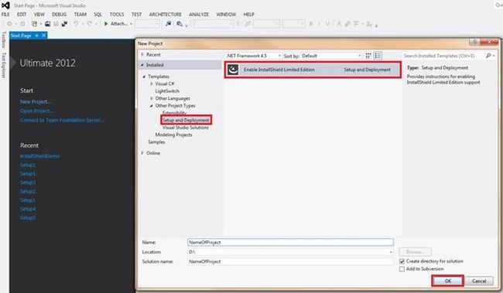
For the first time we need to download software, when we click on the "OK" button as in the above screen it will open a link to download the InstallShield software. It will look as in the following image:
Link: C:\Program Files (x86)\Microsoft Visual Studio 11.0\Common7\IDE\Extensions\InstallShield\InstallShieldProject\1033\InstallShield_ult.html
If you want to download the Express Edition then follow this link:
http://learn.flexerasoftware.com/content/IS-EVAL-InstallShield-Express,
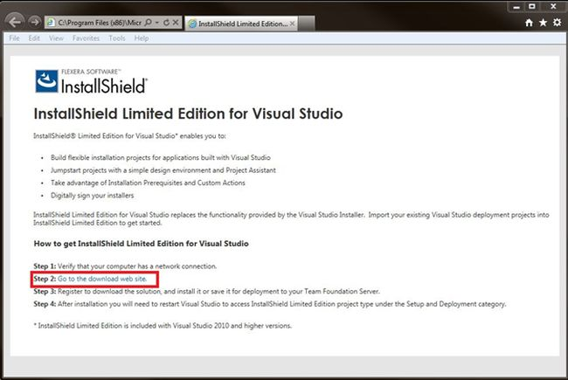
When you click on the Step 2: Go to the Download Web site you will be able to see the page as in the following image. You just have to download the InstallShield LE software from this page.
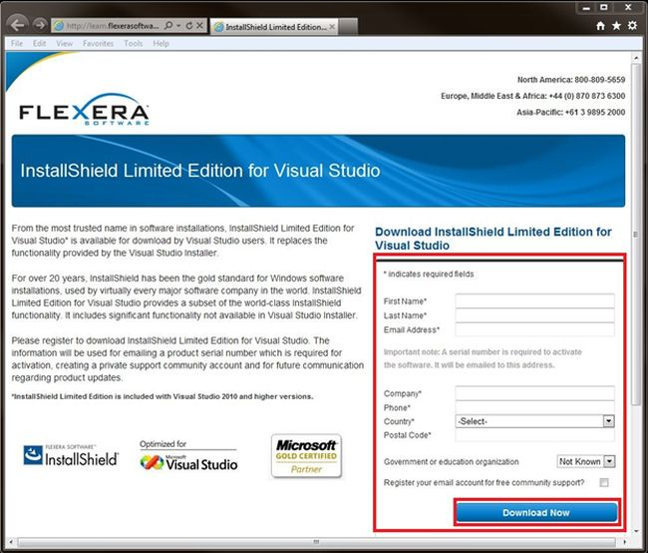
Install it and now open VS2012 and add the InstallShield project to the solution as shown in following image. Here I have added the WPF application as InstallShieldDemo.App and the InstallShield Project as InstallShieldDemo.Deploy.
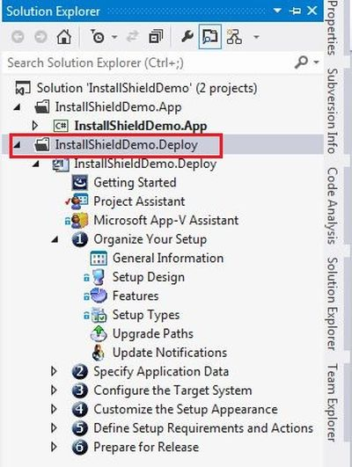
Step 2
Give Application Information
After adding the InstallShield Project you will be able to see this screen:
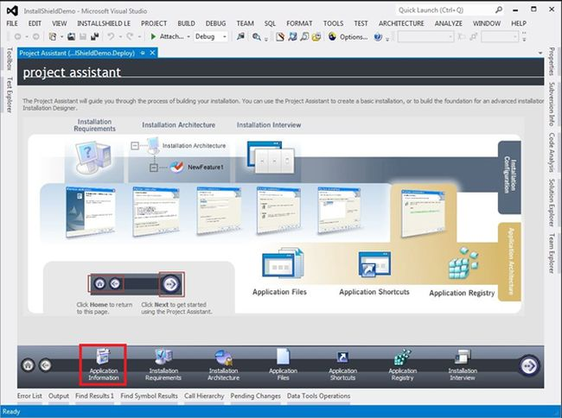
Then click on Application Information in the bottom of the screen and fill in the information.
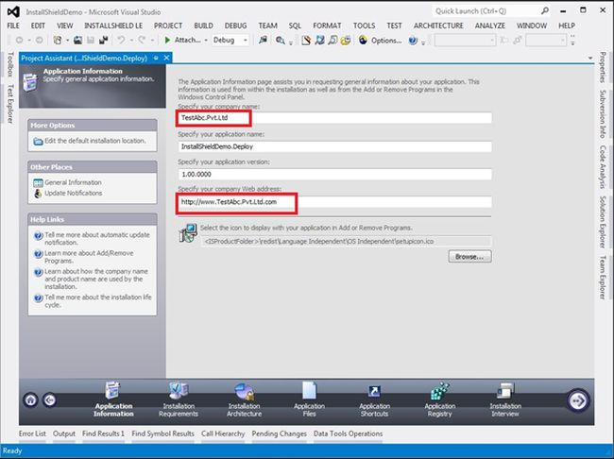
Step 3
Click on Installation Requirements
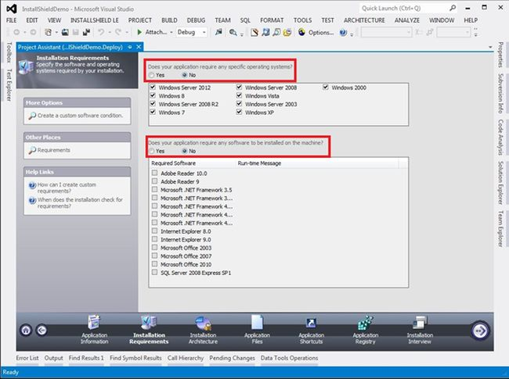
you can specify requirements for your application. It will check for these things before installation of your application. Then and then it will allow installation.
Step 4
Click on Application Files
In InstallShield LE the Installation Architecture feature is not available.
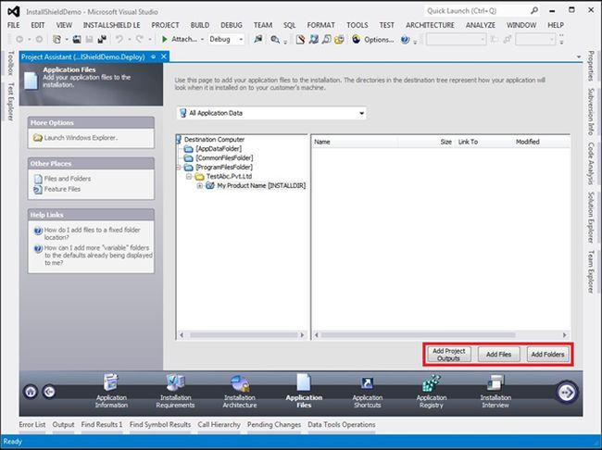
You can use any of these buttons to insert the application output file or necessary files. If your project is located on TFS or any other server then Use Add Project Outputs to add the Projects outputs and other necessary file so you can avoid the problem of a local path reference.
By clicking On Add Project Outputs you can the following image and you can select the options depending on your requirements.
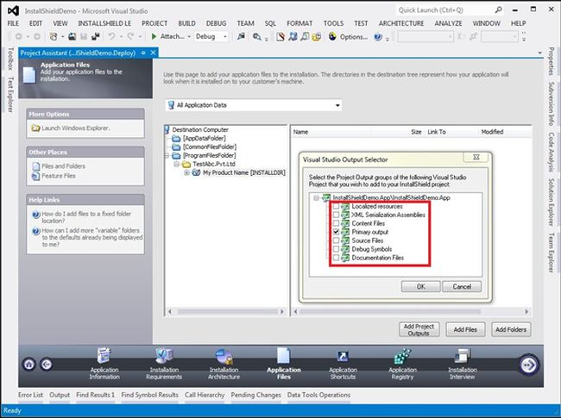
Or you can add the local reference of the output file from application\bin\debug folder.
Step 5
click application shortcuts
here click on new and select the output file.
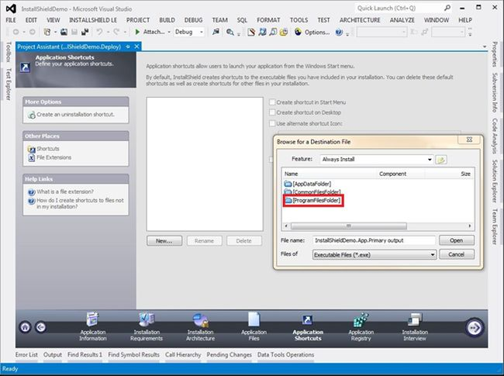
Click on programFilesFolder => TestAbc.Pvt.Ltd => My product Name =>select output file.
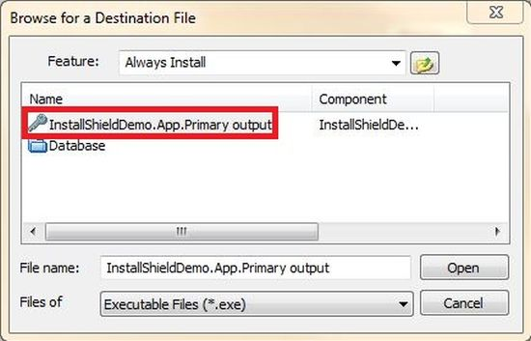
Now you will see this screen:
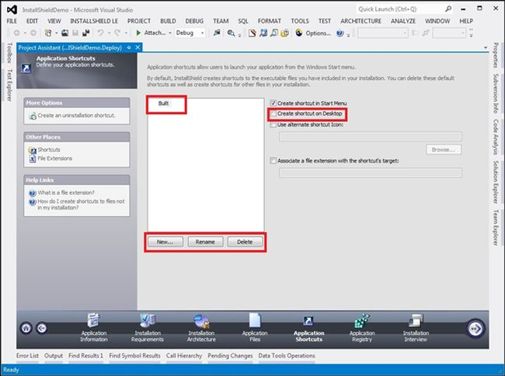
Here you can rename the application.
Step 6
Click on Application Registry
IF your application requires you to change something in the registry then you can use this option:
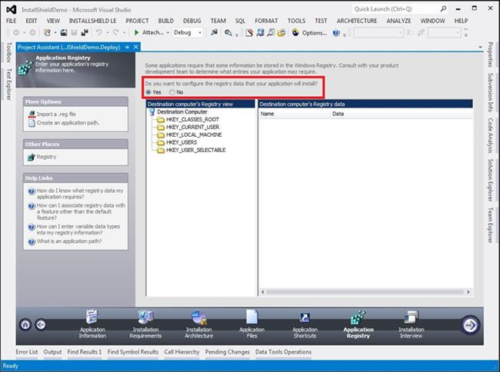
Step 7
Click on Installation interview
Here you can use an option as per your application requirements.
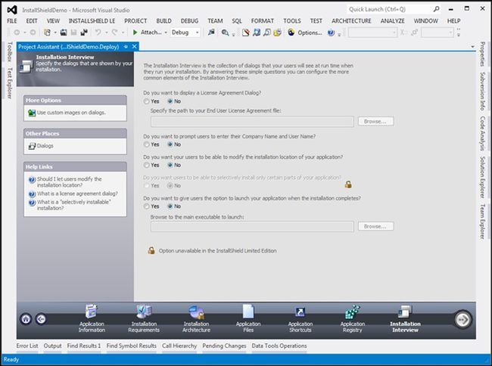
From step 8 all the steps are optional.
Step 8
now go to the Solution Explorer, Select Redistributables option.
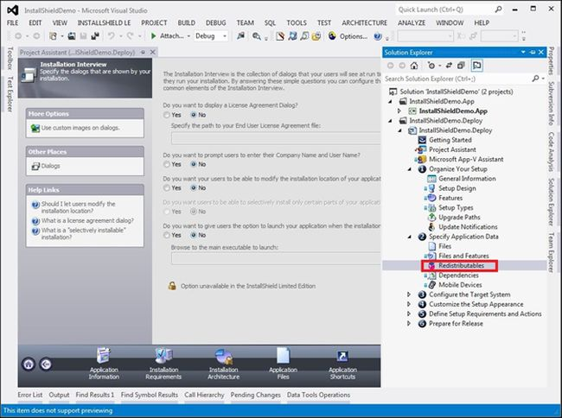
Select the Prerequisite for your application at the client side.
As you can see in the following image I have selected the Microsoft .Net Framework 4.5 full and I have right-clicked it, to select the option. After that it will ask you to download some prerequisite software. Allow that operation; it will add this software to your setup when the setup is created.
The option Extract from steup.exe will combine the prerequisite software to your setup. It will create a single setup file. But you can set for the size to be increased.
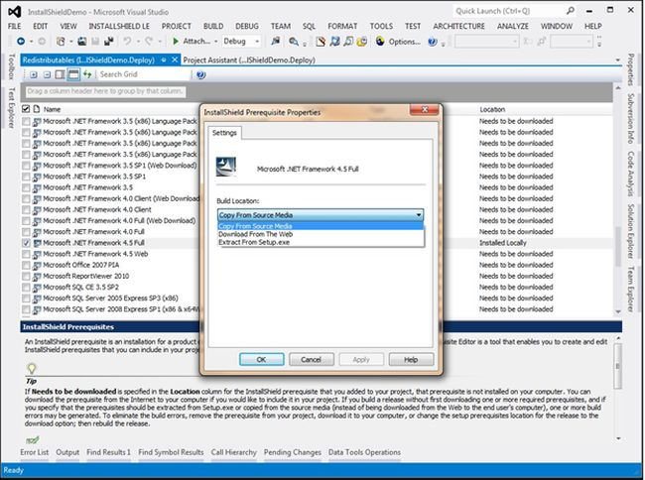
Step 9
If you are getting an error regarding the Icon then do this. Then select the option Shortcuts/Folders from the Solution Explorer.
The error looks like:
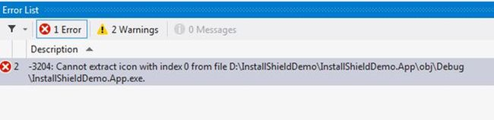
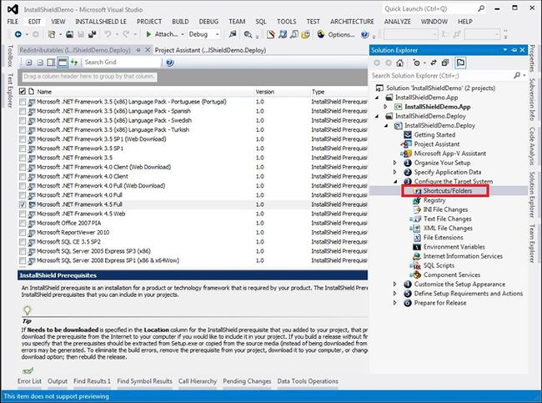
Then give the default icon to the application by giving the icon from the system or you can use any file.
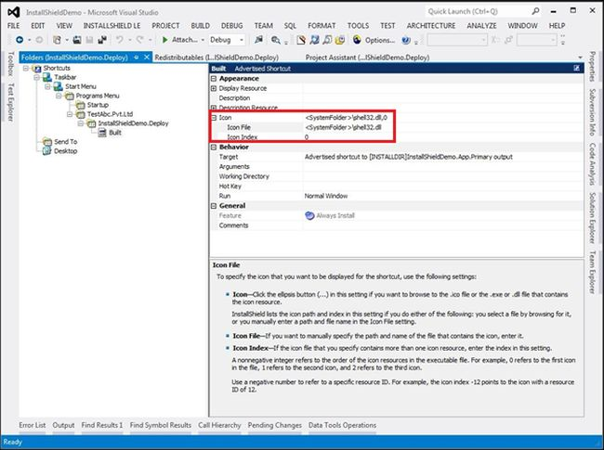
You can change the icon by changing the number of the Icon Index, as in the following image:
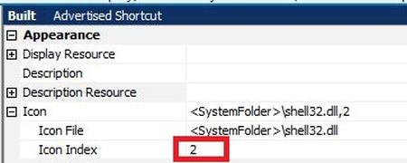
Now build the project. And your setup file will be created.
Go to the path:
Application folder\Express\DVD-5\DiskImages\Disk1\setup
Double-click on setup; it will automatically install the application.
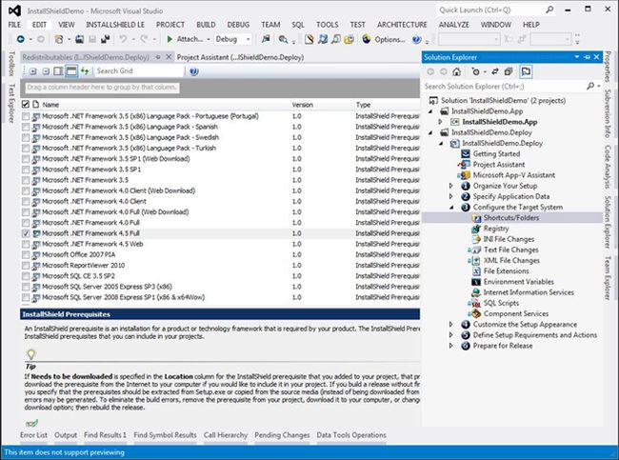
To Create Setup File
We just need to build the project InstallShieldDemo.Deploy from solution Explorer to build the project select the project and right Click on it then select the Build Option.
And you we get the setup file for the application.
Now If you see the setup file folder it will have many more additional Files but if you want to make only Single Setup File then follow the Below steps
Step 1: Select the Project and click on Build option from VS2012 and then select Option Configuration Manager (see the below image)
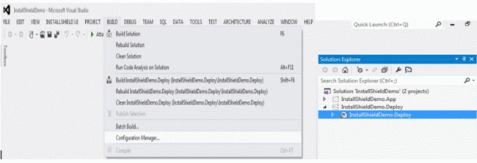
Step 2: Select the option SingleImage (See the below image)
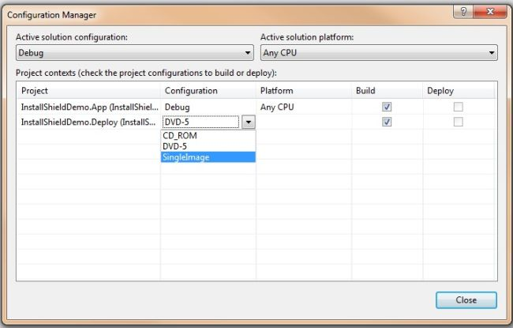
When you see the setup File folder it will contains only one Setup File (see the below Image)
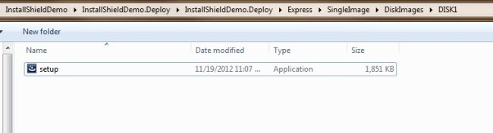
Thank you.

